Citrus Regional Science & Engineering Fair (RSEF) Rules

In accordance with the International Science & Engineering (ISEF) rules, there are some rules of the State Science & Engineering Fair (SSEF) of Florida rules that are more stringent than the official ISEF Rules and Guidelines and there could be some Citrus Regional Science & Engineering Fair (RSEF) rules that may be even more stringent that the SSEF. These additional requirements from SSEF and/or RSEF will take precedence over the International Rules.

ISEF Rules can be found at: ISEF RULES 2018

SSEF Rules can be found at: SSEF RULES 2018

Citrus RSEF Rules:

- Elementary School projects can only be non-protocol projects. Elementary projects dealing with human participants, vertebrates, PHBA - potential hazardous biological agents (bacteria, mold…) and potentially dangerous or hazardous activities, equipment and/or materials (explosions, archery, ballistics…) are not permitted as elementary science fair projects.

- Elementary projects will be required to have the Safety Agreement completed and turned in prior to experimentation as well as complete the State Abstract Form after experimentation.

Abstract form can be found at: 2018 Abstract

Directions for completing Abstract can be found at: 2018 Abstract Directions

- All secondary science fair participants are required to follow all ISEF, SSEF and Citrus RSEF rules, as well as complete all required paperwork, get approval and meet all deadlines to participate in the RSEF.

- Science and/or Engineering projects that are demonstrations, “library” research or informational projects, “explanation” projects, kit building and/or consumer comparison (which popcorn pops the most, which paper towel is most absorbent…) are not appropriate for the RSEF

- The coordination and organization of required paperwork needs to be facilitated by the site-based Science Fair Coordinator(s)

- Before experimentation begins, a school site Institutional Review Board (IRB) and/or Scientific Review Committee (SRC) must review and approve projects involving human participants, vertebrate animals, and potentially hazardous biological agents. (See ISEF rules under “Roles and Responsibilities of Students and Adults” for specific requirements of these committees.)

- ALL PROTOCOL PROJECTS MUST HAVE APPROVAL OF A SCHOOL SITE IRB/SRC COMMITTEE PRIOR TO SENDING THEM TO THE COUNTY REVIEW COMMITTEE.

- Members of the site IRB/SRC Committee must be documented. The official form will be forwarded to the schools when received from the State Director.

- The RSEF Director will be available to assist the site teams with the IRB/SRC process at the individual schools’ request

- Any secondary project involving the use of firearms, archery equipment or any projectile devices must be conducted on a certified safety range with a certified safety officer supervising

- Due dates and requirements listed on the 2016-2017 Citrus RSEF Timeline will be strictly enforced – projects with incomplete paperwork packets will not be eligible to participate in the RSEF.

- For a student to participate in the Citrus RSEF, the site coordinator must register that student on the registration site and have all of the required paperwork turned in to the fair director by December 19th. Incomplete paperwork and missed deadlines are grounds for failure to qualify for the RSEF.

- The RSEF Director will be available to assist the site teams with the paperwork process at the individual schools’ request

- A student must participate in their home school’s science fair. If the student is attending his home school, even for one class, the student must participate in their home school’s science fair

For a student to participate in another school’s science fair, he/she must:
• NOT be taking any classes at their home school during the Fall semester
• Be enrolled at AES that school for the Spring Semester
• Get both schools to be in agreement

- Display Guidelines – The following regulations must be adhered to when exhibiting a project at the Citrus RSEF, FL SSEF and ISEF:
  - Maximum Size:
    - Depth (front to back) 30 inches or 76 centimeters
    - Width (side to side) 48 in or 122 cm
    - Height (floor to top) 108 in or 274 cm
  - The mechanism or frame of the display should conform to the size limitations listed above.
  - You cannot display any other objects, organisms, chemicals and/or equipment with your display. Pictures can be displayed on your projects.
  - If the photographs displayed contain any other student(s) besides those that completed the project, a photo release form needs to be signed by that student’s parents/guardians.
  - The student’s log-book is required to be placed in front of the display
  - Any photos NOT taken by the student researcher or parent, must have the source cited on the display.
  - Your display should include your log-book and all original paperwork signed in blue ink.
  - Abstract must be on the official, current FL SSEF form and be posted vertically on or by the lower left
side of the project.

[-----------------------Height----------------------]

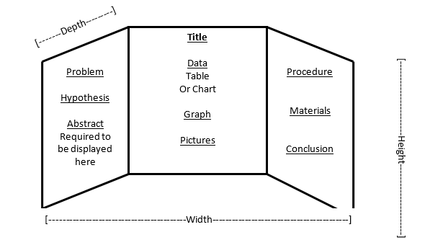

Sponsored by:

